**Coal lab 03**

Name: Syed Muzzamil Waseem

SID: 11067

Question 1

CODE:

INCLUDE Irvine32.inc

.data

;SYED MUZZAMIL WASEEM 11067

msg1 BYTE "Enter value of (a):", 0dh,0ah,0

msg2 BYTE "Enter value of (b):", 0dh,0ah,0

msg3 BYTE "Answer of addition:", 0dh,0ah,0

msg4 BYTE "Answer of subtraction:", 0dh,0ah,0

.code

main PROC

mov edx,offset msg1

call writestring

call readint

mov ebx,eax

mov edx,offset msg2

call writestring

call readint

add eax,ebx

call writeint

call crlf

mov edx,offset msg1

call writestring

call readint

mov ebx,eax

mov edx,offset msg2

call writestring

call readint

sub eax,ebx

call writeint

call crlf

mov edx,offset msg3

call writestring

call readint

mov ebx,eax

mov edx,offset msg4

call writestring

call readint

sub eax,ebx

call writeint

call crlf

call readint

exit

main ENDP

END main

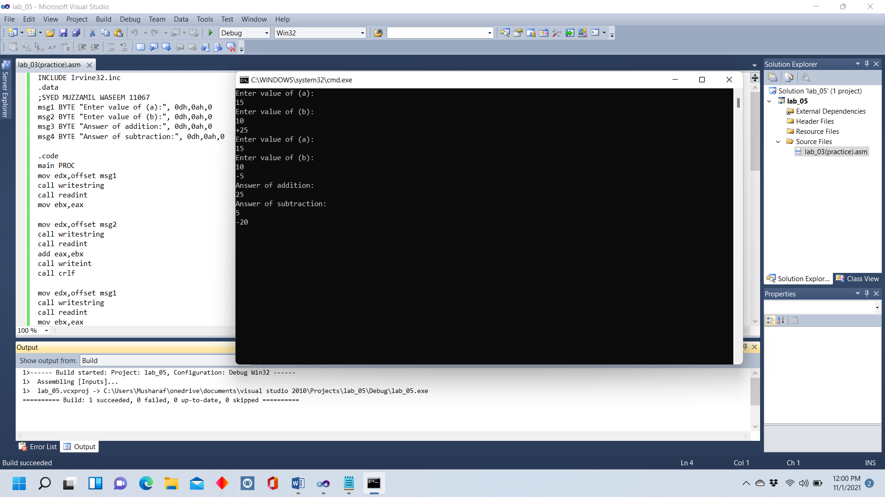

Question 2

CODE:

INCLUDE Irvine32.inc

.data

;SYED MUZZAMIL WASEEM 11067

msg BYTE "Enter value of (a):", 0dh,0ah,0

.code

main PROC

mov edx,offset msg

call writestring

call readint

mov ebx,eax

mul ebx

call crlf

call writeint

exit

main ENDP

END main

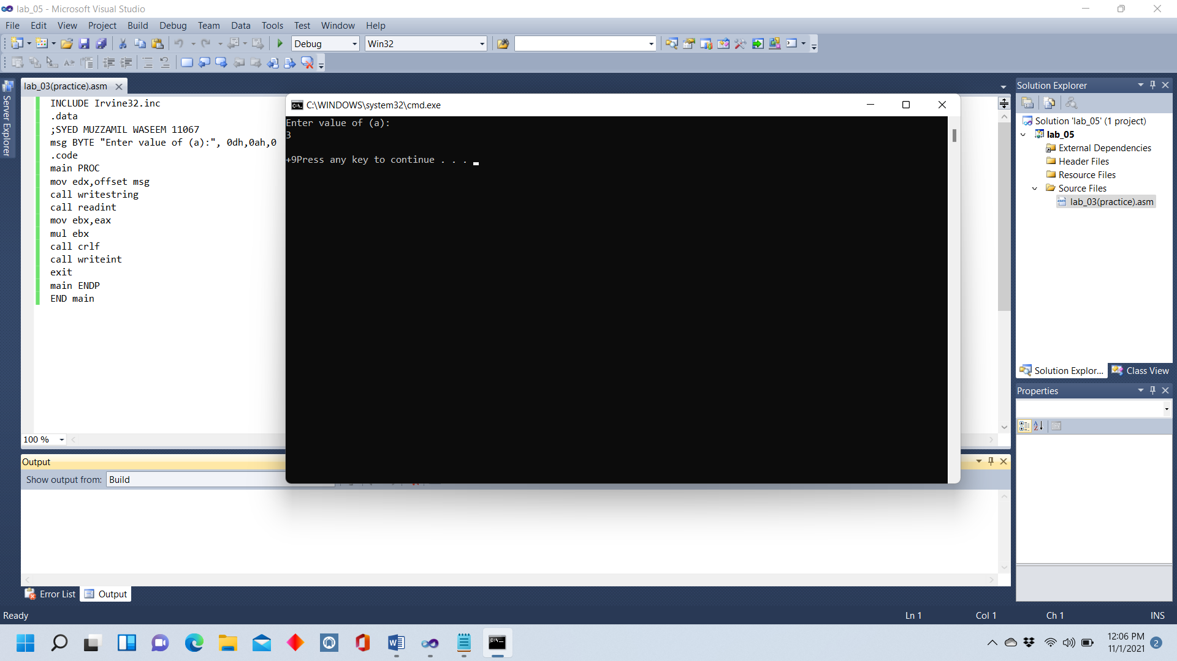

Question 3

CODE:

INCLUDE Irvine32.inc

.data

;SYED MUZZAMIL WASEEM 11067

msg1 BYTE "Enter value of (a):", 0dh,0ah,0

.code

main PROC

mov edx,offset msg1

call writestring

call readint

mov ebx,eax

mul ebx

mov ecx,ebx

mul ecx

call crlf

call writeint

exit

main ENDP

END main

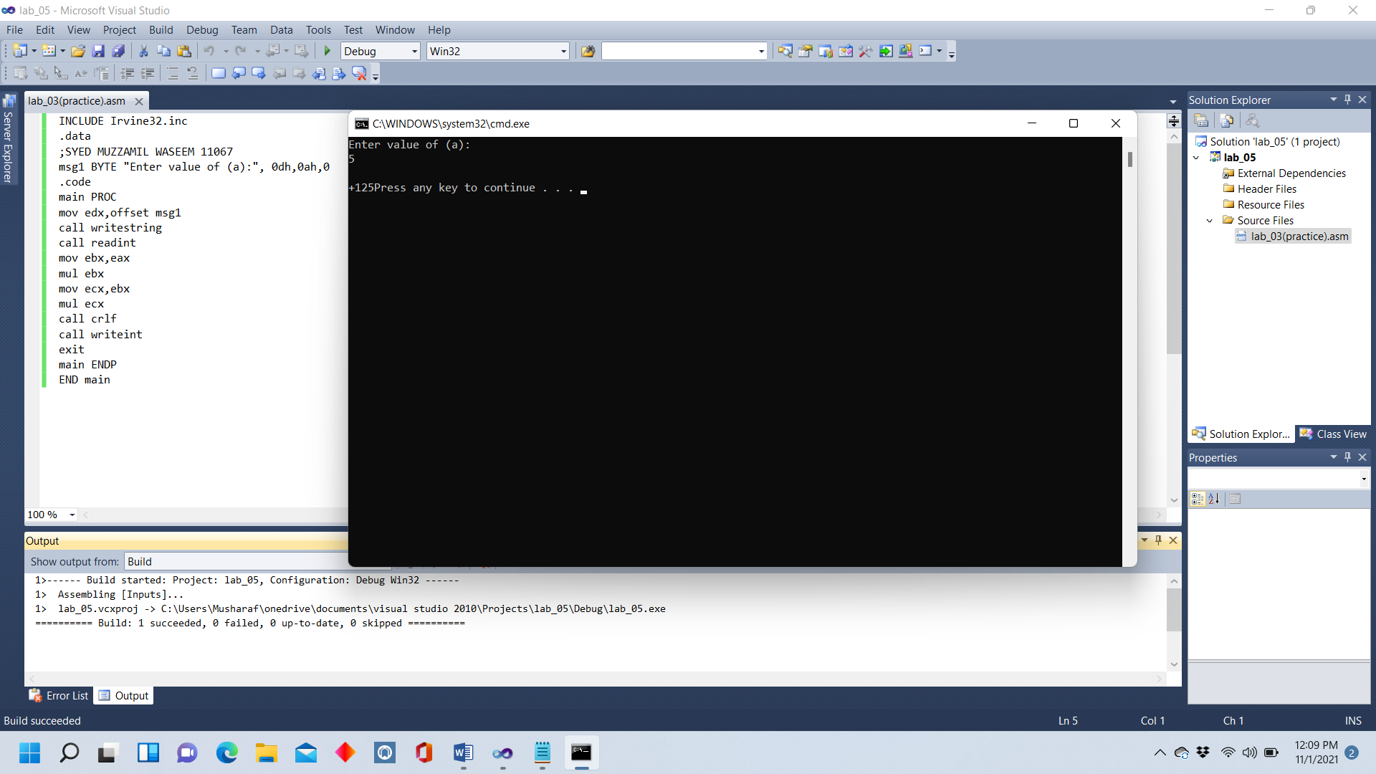

Question 4

CODE:

INCLUDE Irvine32.inc

.data

;SYED MUZZAMIL WASEEM 11067

msg1 BYTE "Enter value of (a):", 0dh,0ah,0

msg2 BYTE "Enter value of (b):", 0dh,0ah,0

msg3 BYTE "Answer of (a):", 0dh,0ah,0

msg4 BYTE "Answer of (b):", 0dh,0ah,0

.code

main PROC

mov edx,offset msg1

call writestring

call readint

mov ebx,eax

mul ebx

call writeint

call crlf

mov edx,offset msg2

call writestring

call readint

mov ebx,eax

mul ebx

call writeint

call crlf

mov edx,offset msg3

call writestring

call readint

mov ebx,eax

mov edx,offset msg4

call writestring

call readint

add eax,ebx

call writeint

call crlf

exit

main ENDP

END main

